

**ARBA MINCH UNIVERSITY**

**ARBA MINCH INSTITUTE OF TECHNOLOGY**

**INTERNSHIP ATTACHMENT REPORT ON**

*“Title of the report here”*

An Internship Report Presented to the

Faculty of Computing and Software Engineering

In Partial Fulfillment of the Requirements for the Degree of

Bachelor of Science in Software Engineering/Computer Science/ Information Technology

**Submitted By**

No. _______________ Student Name ID

**September 30, 2022**

**ABSTRACT**

The Employee Leave is an Intranet based application that can be accessed throughout the organization or a specified group/Dept. This system can be used to automate the workflow of leave applications and their approvals. The periodic crediting of leave is also automated. There are features like cancellation of leave, automatic approval of leave, report generators etc in this Tool.

The project has been planned to be having the view of distributed architecture, with centralized storage of the database. The application for the storage of the data has been planned. Using the constructs of MS-SQL Server and all the user interfaces have been designed using the ASP.Net technologies. The database connectivity is planned using the “SQL Connection” methodology. The standards of security and data protective mechanism have been given a big choice for proper usage. The application takes care of different modules and their associated reports, which are produced as per the applicable strategies and standards that are put forwarded by the administrative staff.

The entire project has been developed keeping in view of the distributed client server computing technology, in mind. The specification has been normalized up to 3NF to eliminate all the anomalies that may arise due to the database transaction that are executed by the general users and the organizational administration. The user interfaces are browser specific to give

**Abbreviations**

1. **Letter of undertaking**
2. **Scanned copy of Internship certificate (provided by the organization)**
3. Acknowledgement The successful completion of this internship report would not have been possible without the support and assistance of many individuals and organizations. We feel immensely blessed to have gotten this during the course of my internship program. We would like to take this opportunity to offer my earnest admiration to each and every one of them. First and foremost, I am highly indebted to Mr.Alemayew(alex) who took confidence in us and provided with the opportunity to work as an Intern at Ethiopia Air Lines. We had a wonderful and an unforgettable experience being part of such a lovely and lively team. I express my sentiment of gratitude to Mr.Fisah, , who has been a continuous source of inspiration as my intern mentor. Without his constant guidance and suggestions, this report would have been nowhere near completion. My gratitude for his trust and generosity goes beyond words. The project specification and help me also by providing working eniveromet by giving Desktop with provided broadband . Finally, thanks and appreciations go to each and every one of my colleagues who irrespective of the situation, always encouraged and supported to prepare this report.
4. **Dedication**

Firstly We dedicate this report to Ethiopia Air Lines company hence this organization is a center of technologies and innovation that have big goal in Transforming our country Ethiopia in many status such economical, agricultural, industrial etc.

not only being our Adviser but our model as well and teaching us everything that we must know to be the wonderful men at my education and Business.

Finally, we would also like to dedicate this report to all my respectable lecturer.

# Chapter 1

# 1.INTRODUCTION

## 1.1 Background of the organization

After the liberation of Ethiopia, Emperor Haile Selassie asked the United States, the United Kingdom, and France to help him to establish an airline as part of his modernization effort.According to the [BBC News](https://en.wikipedia.org/wiki/BBC_News) it is possible that the Emperor intended the creation of a quality national airline to help dispel impressions of Ethiopian poverty.In 1945, the Ethiopian government began negotiations with both [Transcontinental Air Transport](https://en.wikipedia.org/wiki/Transcontinental_Air_Transport) and [Western Air Express](https://en.wikipedia.org/wiki/Western_Air_Express) (later merged into [TWA](https://en.wikipedia.org/wiki/TWA)). On 8 September 1945, TWA signed an agreement with the American historian and foreign affairs advisor to Ethiopia [John H. Spencer](https://en.wikipedia.org/wiki/John_H._Spencer) to establish a commercial aviation company in Ethiopia.

Brief history

Ethiopian Airlines (Ethiopian) is the flag carrier of Ethiopia. During the past seventy plus years, Ethiopian has become one of the continent's leading carriers, unrivalled in Africa for efficiency and operational success, turning profits for almost all the years of its existence. Operating at the forefront of technology, the airline has also become one of Ethiopia's major industries and a veritable institution in Africa. It commands a lion's share of the pan African network including the daily and double daily east-west flight across the continent. Ethiopian currently serves 127 international and 22 domestic destinations operating the newest and youngest fleet.

Founded: December 21, 1945

Starting date of operation: April 08, 1946

Ownership: Government of Ethiopia (100%)

Website: http://www.ethiopianairlines.com

Chief Executive Officer: Mr. Mesfin Tasew

Passenger Airport Terminal: The Addis Ababa Bole International Airport is the major hub for Ethiopian Airlines and one of the largest airports in Africa. The ultra-modern airport terminal was inaugurated on January 21, 2003. This spacious terminal handles all international flights with its 21st century facilities. Addis Ababa Airport is the busiest airport in East Africa with a capacity of providing a world class passenger and cargo services to more than 22 million international and domestic passengers each year.

## Vision

To become the most competitive and leading aviation group in Africa by providing safe, market driven and customer focused passenger and cargo transport, aviation training, flight catering, MRO and ground services by 2025.

## Mission

To become the leading Aviation group in Africa by providing safe and reliable passenger and cargo air transport, Aviation Training, Flight Catering, MRO and Ground Services whose quality and price “value proposition” is always better than its competitors, To ensure being an airline of choice to its customers, employer of choice to its employees and an investment of choice to its Owner, To contribute positively to socio economic development of Ethiopia in particular and the countries to which it operates in general by undertaking its corporate social responsibilities and providing vital global air connectivity,

## Values

As an airline, safety is our first priority, Ethiopian is a high performance and learning organization with continuous improvements, innovation and knowledge-sharing. We accept change for the growth opportunity it brings and always seek for and apply the best ideas regardless of their source, We recognize and reward employees for their performance and demonstrate integrity, respect to others, candor and team work, Act in an open fashion and be result-oriented, creative and innovative, Adopt Zero tolerance to indifference, inefficiency and bureaucracy, Encourage 360° free flow and sharing of information, Treat our customers the same way we would like to be treated and always look for ways to make it easier for customers to do business with us, We are an equal opportunity employer

Project Schedule

|  |  |  |
| --- | --- | --- |
|  |  |  |
|  |  |  |
|  |  |  |
|  |  |  |

1.4.1 Time Schedule As per the requirement of the Arba minch University We had done internship for 4 months dated from 24th oct , 2014 E.C to 30nd ja, 2014E.C. During these 4 months we have done online Employee Leave Management System Ethiopian Air Lines complete projects, and the time spent on variou s topics is as follow:

|  |  |  |
| --- | --- | --- |
|  |  |  |
|  |  |  |
|  |  |  |
|  |  |  |
|  |  |  |
|  |  |  |

* Introduction of the organization
* Policy of the organization
* Competitors

**1.2. INTRODUCTION TO PROJECT**

The Employee Leave is an Intranet based application that can be accessed throughout the organization or a specified group/Dept. This system can be used to automate the workflow of leave applications and their approvals. The periodic crediting of leave is also automated. There are features like cancellation of leave, automatic approval of leave, report generators etc in this Tool.

The project has been planned to be having the view of distributed architecture, with centralized storage of the database. The application for the storage of the data has been planned. Using the constructs of MS-SQL Server and all the user interfaces have been designed using the ASP.Net technologies. The database connectivity is planned using the “SQL Connection” methodology. The standards of security and data protective mechanism have been given a big choice for proper usage. The application takes care of different modules and their associated reports, which are produced as per the applicable strategies and stand-[ards that are put forwarded by the administrative staff.

* 1. **PURPOSE OF THE PROJECT**

This project is aimed at developing a web based Leave Management Tool, which is of importance to either an organization or a college. This is an Intranet based application that can throughout the organization or a specified group/Dept. This system can be used to automate the workflow of leave applications and their approvals. The periodic crediting of leave is also automated. There are features like email notifications, cancellation ofbe accessed leave, automatic approval of leave, report generators etc in this Tool.

* 1. **SOLUTION OF THESE PROBLEMS**

The development of the new system contains the following activities, which try to automate the entire process keeping in view of the database integration approach.

1. User friendliness is provided in the application with various controls.
2. The system makes the overall project management much easier and flexible.
3. Readily upload the latest updates, allows user to download the alerts by clicking the URL.
4. There is no risk of data mismanagement at any level while the project development is under process.
5. It provides high level of security with different level of authentication.

**Chapter 2**

**SYSTEM ANALYSIS**

**2.1. INTRODUCTION**

After analyzing the requirements of the task to be performed, the next step is to analyze the problem and understand its context. The first activity in the phase is studying the existing system and other is to understand the requirements and domain of the new system. Both the activities are equally important, but the first activity serves as a basis of giving the functional specifications and then successful design of the proposed system. Understanding the properties and requirements of a new system is more difficult and requires creative thinking and understanding of existing running system is also difficult, improper understanding of present system can lead diversion from solution.

**2.2. STUDY OF THE SYSTEM**

# GUI’S

In the flexibility of the uses the interface has been developed a graphics concept in mind, associated through a browses interface. The GUI’S at the top level have been categorized as

1. Administrative user interface
2. The operational or generic user interface

The administrative user interface concentrates on the consistent information that is practically, part of the organizational activities and which needs proper authentication for the data collection. The interfaces help the administrations with all the transactional states like Data insertion, Data deletion and Date updation along with the extensive data search capabilities.

The operational or generic user interface helps the users upon the system in transactions through the existing data and required services. The operational user interface also helps the ordinary users in managing their own information helps the ordinary users in managing their own information in a customized manner as per the assisted flexibilities.

# NUMBER OF MODULES

The system after careful analysis has been identified to be presented with the following modules:

**The modules involved are:**

* Administration
* Employee
* Search
* Report
* Authentication

Administrator:-

In this module the Administrator has the privileges to add all the Employees and register them in the organization and check the information of the Employee and check the status of the leave when they have taken and what type of leave they have taken and search is done based on the employee and report is generated based on employee.

Search:-

This module contain complete search like Leave search, Type of Leave, Employee based on the leave and starting and ending day of leave.

Employee:-

In this module employee has the privileges to use his username and password for login and he can see the request given by the customer and he can pass the process to the Business Manager and maintain the record of the customers.

Reports:-

This module contains all the information about the reports generated by the Employees based on the Performance and by the leave status.

Authentication:-

This module contains all the information about the authenticated user. User without his username and password can’t enter into the login if he is only the authenticated user then he can enter to his login.

**2.4. HARDWARE SPEDIFICATIONS**

**HARDWARE REQUIREMENTS:**

* PIV 2.8 GHz Processor and Above
* RAM 4GB and Above
* HDD 20 GB Hard Disk Space and Above

**SOFTWARE REQUIREMENTS:**

* WINDOWS OS (XP / 2000 / 200 Server / 2003 Server)
* Visual Studio .Net 2022 Enterprise Edition
* Internet Information Server 5.0 (IIS)
* Visual Studio .Net Framework (Minimal for Deployment)
* SQL Server 2000 Enterprise Edition

**2.5. PROPOSED SYSTEM**

To debug the existing system, remove procedures those cause data redundancy, make navigational sequence proper. To provide information about audits on different level and also to reflect the current work status depending on organization/auditor or date. To build strong password mechanism.

We all know the importance of computerization. The world is moving ahead at lightning speed and everyone is running short of time. One always wants to get the information and perform a task he/she/they desire(s) within a short period of time and too with amount of efficiency and accuracy. The application areas for the computerization have been selected on the basis of following factors:

* Minimizing the manual records kept at different locations.
* There will be more data integrity.
* Facilitating desired information display, very quickly, by retrieving information from users.
* Facilitating various statistical information which helps in decision-making?
* To reduce manual efforts in activities that involved repetitive work.
* Updating and deletion of such a huge amount of data will become easier.

**2.7. PROCESS MODELS USED WITH JUSTIFICATION**

### ACCESS CONTROL FOR DATA WHICH REQUIRE USER AUTHENTICATION

The following commands specify access control identifiers and they are typically used to authorize and authenticate the user (command codes are shown in parentheses)

**USER NAME (USER)**

The user identification is that which is required by the server for access to its file system. This command will normally be the first command transmitted by the user after the control connections are made (some servers may require this).

**PASSWORD (PASS)**

This command must be immediately preceded by the user name command, and, for some sites, completes the user's identification for access control. Since password information is quite sensitive, it is desirable in general to "mask" it or suppress type out.

**Chapter 3**

**Feasibility Report**

Preliminary investigation examine project feasibility, the likelihood the system will be useful to the organization. The main objective of the feasibility study is to test the Technical, Operational and Economical feasibility for adding new modules and debugging old running system. All system is feasible if they are unlimited resources and infinite time. There are aspects in the feasibility study portion of the preliminary investigation:

* Technical Feasibility
* Operation Feasibility
* Economic Feasibility

**3.1. Technical Feasibility**

The technical issue usually raised during the feasibility stage of the investigation includes the following:

* Does the necessary technology exist to do what is suggested?
* Do the proposed equipment’s have the technical capacity to hold the data required to use the new system?
* Will the proposed system provide adequate response to inquiries, regardless of the number or location of users?
* Can the system be upgraded if developed?
* Are there technical guarantees of accuracy, reliability, ease of access and data security?

Earlier no system existed to cater to the needs of ‘Secure Infrastructure Implementation System’. The current system developed is technically feasible. It

is a web based user interface. Thus it provides an easy access to the users. The database’s purpose is to create, establish and maintain a workflow among various entities in order to facilitate all concerned users in their various capacities or roles. Permission to the users would be granted based on the roles specified. Therefore, it provides the technical guarantee of accuracy, reliability and security. The software and hard requirements for the development of this project are not many and are available as free as open source. The work for the project is done with the current equipment and existing software technology. Necessary bandwidth exists for providing a fast feedback to the users irrespective of the number of users using the system.

**3.2. Operational Feasibility**

Proposed projects are beneficial only if they can be turned out into information system. That will meet the organization’s operating requirements. Operational feasibility aspects of the project are to be taken as an important part of the project implementation. Some of the important issues raised are to test the operational feasibility of a project includes the following: -

* Is there sufficient support for the management from the users?
* Will the system be used and work properly if it is being developed and implemented?
* Will there be any resistance from the user that will undermine the possible application benefits?

This system is targeted to be in accordance with the above-mentioned issues. Beforehand, the management issues and user requirements have been taken into consideration. So there is no question of resistance from the users that can undermine the possible application benefits.

The well-planned design would ensure the optimal utilization of the computer resources and would help in the improvement of performance status.

**3.3. Economic Feasibility**

A system can be developed technically and that will be used if installed must still be a good investment for the organization. In the economic feasibility, the development cost in creating the system is evaluated against the ultimate benefit derived from the new systems. Financial benefits must equal or exceed the costs.

The system is economically feasible. It does not require any addition hardware or software. Since the interface for this system is developed using the existing resources and technologies. There is nominal expenditure and economic feasibility for certain.

**Chapter 4**

**SOFTWARE REQUIREMENT SPECIFICATION**

The software, Site Explorer is designed for management of web sites from a remote location.

**INTRODUCTION**

**Purpose:** The main purpose for preparing this document is to give a general insight into the analysis and requirements of the existing system or situation and for determining the operating characteristics of the system.

**Scope:** This Document plays a vital role in the development life cycle (SDLC) and it describes the complete requirement of the system. It is meant for use by the developers and will be the basic during testing phase. Any changes made to the requirements in the future will have to go through formal change approval process.

**DEVELOPERS RESPONSIBILITIES OVERVIEW:**

The developer is responsible for:

* Developing the system, which meets the SRS and solving all the requirements of the system?
* Demonstrating the system and installing the system at client's location after the acceptance testing is successful.
* Submitting the required user manual describing the system interfaces to work on it and also the documents of the system.
* Conducting any user training that might be needed for using the system.
* Maintaining the system for a period of one year after installation.

## 4.1. FUNCTIONAL REQUIREMENTS:

**OUTPUT DESIGN:**

Outputs from computer systems are required primarily to communicate the results of processing to users. They are also used to provides a permanent copy of the results for later consultation.

**INPUT DESIGN**

Input design is a part of overall system design. The main objective during the input design is as given below:

* To produce a cost-effective method of input.
* To achieve the highest possible level of accuracy.
* To ensure that the input is acceptable and understood by the user.

**ERROR AVOIDANCE**

At this stage care is to be taken to ensure that input data remains accurate form the stage at which it is recorded upto the stage in which the data is accepted by the system. This can be achieved only by means of careful control each time the data is handled.

**ERROR DETECTION**

Even though every effort is make to avoid the occurrence of errors, still a small proportion of errors is always likely to occur, these types of errors can be discovered by using validations to check the input data.

**DATA VALIDATION**

Procedures are designed to detect errors in data at a lower level of detail. Data validations have been included in the system in almost every area where there is a possibility for the user to commit errors.

**USER INTERFACE DESIGN**

**A. USER_INITIATED INTERGFACES**

User initiated interfaces fall into tow approximate classes:

1. Command driven interfaces: In this type of interface the user inputs commands or queries which are interpreted by the computer.
2. Forms oriented interface: The user calls up an image of the form to his/her screen and fills in the form. The forms oriented interface is chosen because it is the best choice.

**B. COMPUTER-INITIATED INTERFACES**

The following computer – initiated interfaces were used:

1. The menu system for the user is presented with a list of alternatives and the user chooses one; of alternatives.
2. Questions – answer type dialog system where the computer asks question and takes action based on the basis of the users reply.

**ERROR MESSAGE DESIGN:**

The design of error messages is an important part of the user interface design. As user is bound to commit some errors or other while designing a system the system should be designed to be helpful by providing the user with information regarding the error he/she has committed.

**4.2. PERFORMANCE REQUIREMENTS**

Performance is measured in terms of the output provided by the application.

Requirement specification plays an important part in the analysis of a system. Only when the requirement specifications are properly given, it is possible to design a system, which will fit into required environment. It rests largely in the part of the users of the existing system to give the requirement specifications because they are the people who finally use the system. This is because the requirements have to be known during the initial stages so that the system can be designed according to those requirements. It is very difficult to change the system once it has been designed and on the other hand designing a system, which does not cater to the requirements of the user, is of no use.

The requirement specification for any system can be broadly stated as given below:

• The system should be able to interface with the existing system

• The system should be accurate

• The system should be better than the existing system

The existing system is completely dependent on the user to perform all the duties.

**Chapter 5**

# SYSTEM DESIGN

**5.1. OVERVIEW TO .NET Framework**

# ASP.NET Core MVC is a rich framework for building web apps and APIs using the Model-View-Controller design pattern.

**MVC pattern**

The Model-View-Controller (MVC) architectural pattern separates an application into three main groups of components: Models, Views, and Controllers. This pattern helps to achieve separation of concerns. Using this pattern, user requests are routed to a Controller which is responsible for working with the Model to perform user actions and/or retrieve results of queries. The Controller chooses the View to display to the user, and provides it with any Model data it requires.

The following diagram shows the three main components and which ones reference the others:

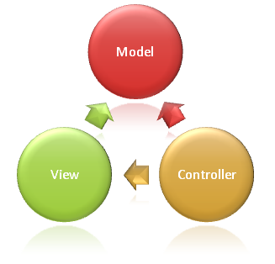  
This delineation of responsibilities helps you scale the application in terms of complexity because it's easier to code, debug, and test something (model, view, or controller) that has a single job. It's more difficult to update, test, and debug code that has dependencies spread across two or more of these three areas. For example, user interface logic tends to change more frequently than business logic. If presentation code and business logic are combined in a single object, an object containing business logic must be modified every time the user interface is changed. This often introduces errors and requires the retesting of business logic after every minimal user interface change.

**Model Responsibilities**

The Model in an MVC application represents the state of the application and any business logic or operations that should be performed by it. Business logic should be encapsulated in the model, along with any implementation logic for persisting the state of the application. Strongly-typed views typically use ViewModel types designed to contain the data to display on that view. The controller creates and populates these ViewModel instances from the model.

**View Responsibilities**

Views are responsible for presenting content through the user interface. They use the Razor view engine to embed .NET code in HTML markup. There should be minimal logic within views, and any logic in them should relate to presenting content. If you find the need to perform a great deal of logic in view files in order to display data from a complex model, consider using a View Component, ViewModel, or view template to simplify the view.

**Controller Responsibilities**

Controllers are the components that handle user interaction, work with the model, and ultimately select a view to render. In an MVC application, the view only displays information; the controller handles and responds to user input and interaction. In the MVC pattern, the controller is the initial entry point, and is responsible for selecting which model types to work with and which view to render (hence its name - it controls how the app responds to a given request).

## Razor view engine

Razor is used to dynamically generate web content on the server. You can cleanly mix server code with client side content and code and also MVC can be strongly typed based on your model. Controllers can pass a strongly typed model to views enabling your views to have type checking and IntelliSense support.

**SQL SERVER**

A database management, or DBMS, gives the user access to their data and helps them transform the data into information. Such database management systems include dBase, paradox, IMS, SQL Server and SQL Server. These systems allow users to create, update and extract information from their database.

A database is a structured collection of data. Data refers to the characteristics of people, things and events. SQL Server stores each data item in its own fields. In SQL Server, the fields relating to a particular person, thing or event are bundled together to form a single complete unit of data, called a record (it can also be referred to as raw or an occurrence). Each record is made up of a number of fields. No two fields in a record can have the same field name.

During an SQL Server Database design project, the analysis of your business needs identifies all the fields or attributes of interest. If your business needs change over time, you define any additional fields or change the definition of existing fields.

**CONTEXT DIAGRAM**

**Administrator**

**Employee**

**Authentication**

**Report**

**Search**

**Provide services**

**Receive Report**

**Emp**

**_details**

**Emp_id**

**Search_id**

**Search Details**

**Report_id**

**Report Details**

**Use Case Diagram**

Use-cases are derived from functional requirements. A use case diagram at its simplest is a representation of a user's interaction with the system that shows the relationship between the user and the different use cases in which the user is involved. The use case diagram plays very important role to capture the dynamic behavior of the application´s system and to represent the user´s interaction with the system

# USECASE FOR ADMIN

Search for Employee

Search for Status



**Admin**

Register Employee

Search for Employee

**Employee**

**SEQUENCE DIAGRAMS**

Sequence Diagrams Represent the objects participating the interaction horizontally and time vertically.

**SEQUENCE DIAGRAM 1**

Time

Admin

Home Page

Database

Admin Home Page

Use URL

Press login button

If Yes Goes to its Home Page

If No Come Back to Home Page

Validate if NO

**SEQUENCE DIAGRAM 2**

Employee Home Page

Database

Home Page

Employee

Use URL

Press login button

Validate if NO

If No Come Back to Home Page

If Yes Goes to its Home Page

Time

ER Diagram

• The relation upon the system is structure through a conceptual ER-Diagram, which not only specifics the existential entities but also the standard relations through which the system exists and the cardinalities that are necessary for the system state to continue.

• The entity Relationship Diagram (ERD) depicts the relationship between the data objects. The ERD is the notation that is used to conduct the date modeling activity the attributes of each data object noted is the ERD can be described resign a data object descriptions.

• The set of primary components that are identified by the ERD are

• Data object

• Relationships

• Attributes

• Various types of indicators.

The primary purpose of the ERD is to represent data objects and their relationships.

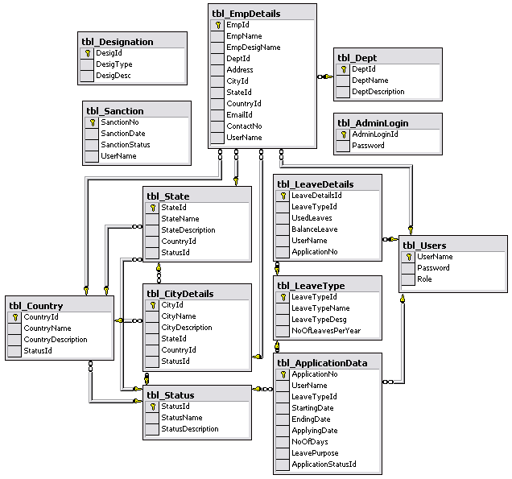

**Activity Diagram**

**Login Activity:**

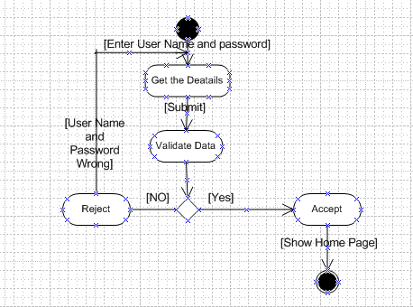

**User Registration Activity**

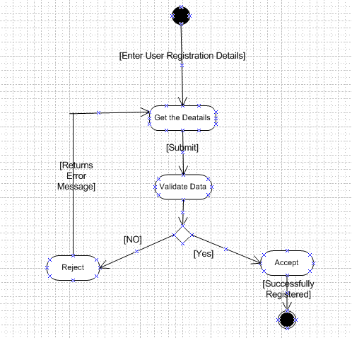

**Class Diagram**

**Collaboration Diagram**



